IX/ CS/TRIANGLE

Triangles are used in bridges because they evenly distribute weight without changing their proportions. When force is applied on a shape like rectangle it would flatten out. Before triangles were used in bridges, they were weak and could not be very big. To solve that problem engineers would put a post in the middle of a square and make it more sturdy. Isosceles triangles were used to construct a bridge in which the base and equal sides of an isosceles triangle are in the ratio 1:2:2 and its perimeter is 200 m.

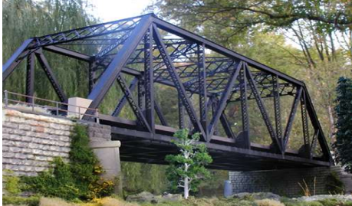

1. What is the value of the common ratio?
2. What are the measurements of the sides of an isosceles triangle?
3. Find the semi-perimeter of the above triangle.
4. What is the area of the above isosceles triangle?
5. Find the cost of painting the so formed triangle at the rate of ₹ 18.25 per 𝑚2 .